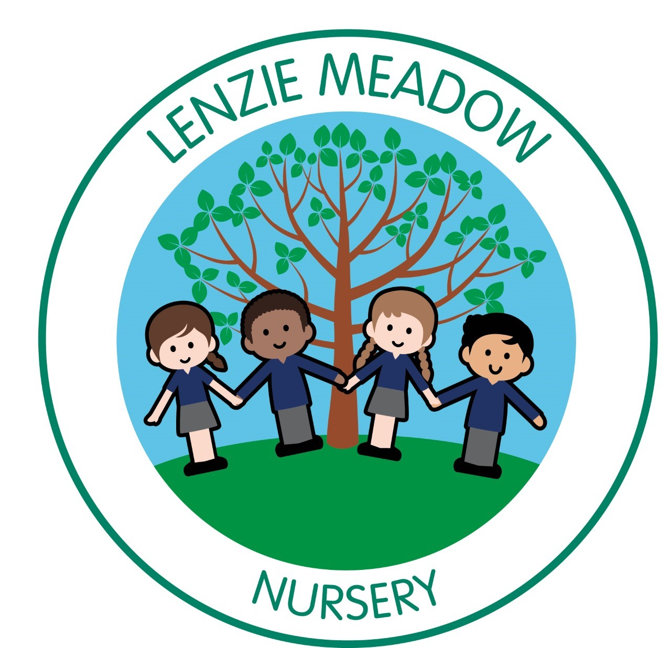

Handbook 2026/2027

Centre Information

Name of Centre: Lenzie Meadow Early Years Centre

Address: Moss Road, Lenzie, G64 1DL

Telephone No: 0141 955 2367

Email Address: nursery@lenziemeadow.e-dunbarton.sch.uk

Web Address: http://www.lenziemeadow.e-dunbarton.sch.uk/

Head of centre / Depute Heads of centre
Rona Wallace (Head Teacher)
Claire Moore (DHOC)
Laura Mesarowicz (DHOC)

Introduction to Our Centre

Lenzie Meadow Primary and Early years’ centre was established on 18th August 2016, bringing together learners and staff from Lenzie Primary School and Lenzie Moss Primary School. In our early years centre we can accommodate 54:54 3 to 5 year olds and a 10:10 provision for 2 year olds. The early years’ centre offers extended day/ extended year provision.
We operate a staff/child ratio established by the Care Inspectorate Scotland. The 2-3 Room operates with 1 staff member to 5 children and the 3-5 Room is 1 staff member to 8 children for extended day provision.
OUR VISION
To create learners who are: Happy, Self-confident, Motivated and Responsible individuals who strive to achieve their very best in all pursuits.

OUR VALUES
- Be Kind
- Be Safe
- Be Responsible
- Be Determined
WE AIM TO:
- enable individuals to achieve their full potential, academically and socially
- foster a spirit of independence
- promote positive attitudes in our school community with an emphasis on respect for oneself and others
- ensure equality of opportunity for all within an inclusive environment
- to develop a sense of caring, trust and honesty in all learners
We work in partnership with our parents and the wider Lenzie Meadow School Community to build the very best in achievement and attainment for all.

OUR STAFF
Senior early years worker | Kirsty- Nursery Teacher
Lisa Burke (Mon/ tues)  Heather Hill (Wed/ Thurs/ Fri) | Talia- Early Years support worker
Lisa Burke (Mon/ tues)  Heather Hill (Wed/ Thurs/ Fri) | Angela- Clerical Assistant
Lisa Burke (Mon/ tues)  Heather Hill (Wed/ Thurs/ Fri) | Mila- Housekeeper
2 to 3 room staff | 3 to 5 room staff
Louise  Nicola  Lorna | Lesley  Wendy  Lauren  Sharon  Debbie  Lisa  Kirsty  Grant  Rachel Mc  Rachel J  Tracey  Suzanne  Emma  Karen

Admissions

All nursery places are allocated in line with the East Dunbartonshire Council’s admissions policy and the Head of Centre will be happy to advise you how on this policy operates when you apply for a place for your child. An Admissions policy is available from the East Dunbartonshire website. Early years admissions policy - East Dunbartonshire Council

Registering for Nursery
Parents wishing to apply for a nursery place are required to complete an online application at: Early years - how to apply - East Dunbartonshire Council

Parents applying for place must upload the following items to the website:
• The Child’s birth certificate
• Proof of residency (council tax bill)
• Recent utility bill (within past 3 months)

If you are allocated a place at our Early Years Centre, you will be informed by East Dunbartonshire Council. Parents can ask to see their application form at any time. The Depute Head of Centre will arrange settling in dates and details of enrolment procedures.

Every family is entitled to one alteration per term, if required the alteration request form can be found on the East Dunbartonshire website. Please speak with Depute Head of Centre to discuss any potential alterations.

Settling in Procedure
For the initial visit to the Centre, we will invite yourself and your child to have a walk round and meet the staff to help familiarise them with the room. There will also be some paperwork for you to complete. After this, a start date will be discussed and settling in visits arranged. The room staff will inform you of the procedures and routine of the day and will answer any questions you may have.

Attendance
Although there is no statutory attendance procedure in pre-five establishments you are asked to ensure that your child attends nursery regularly. If your child is absent, please telephone or email the nursery direct and let us know the reason for his/her absence. We follow East Dunbartonshire’s policy and it is the responsibility of every parent to contact the office before 9.30am or 1.30pm and inform the staff why your child is not in attendance. If this does not happen, the office staff will phone the home and emergency contact. In some exceptional circumstances, where the school/nursery believes your child could be at risk of harm, contact will be made with the Police and/or Social Work. These measures are put in place under the Child Protection Policy.
Arrival and Collection of Children
It is expected that a responsible adult will bring your child to and from the Centre. To ensure the smooth running of the service, please make sure your child is collected at the correct time. In the interests of your child’s safety, you should make a point of telling the staff members if your child is to be collected by someone else. The adult must be known to the child. This avoids difficult situations when a child cannot be allowed to leave with an adult who is a stranger to the staff. Please ensure this person knows the password you put on the enrolment Form.

Emergency Contacts
Parents whose children are in the nursery are asked where possible to provide the establishment with the names, addresses and telephone numbers of two contact persons for use in case of an emergency in addition to parent/ carer info. Please ensure that the nursery have been informed of any change in home telephone number, main email contact and/or address.

Suitable Clothing

It is very important that all clothes are labelled as a number of children have the same or similar items
of clothing. Children have the best fun when they are doing messy work. We will always try to make sure
they wear aprons but accidents happen so please dress your child in suitable clothes. The Centre will
provide welly boots and waterproof clothes for outdoor play.

As part of East Dunbartonshire Council’s policy on dress code, there are forms of dress which are deemed unacceptable in our nursery, such as items of clothing which:

- potentially, encourage factions (such as football colours);
- could cause offence (such as anti-religious symbolism or political slogans)
- could cause health and safety difficulties, such as loose fitting clothing, dangling earrings – please note, there is a requirement that all jewellery is removed prior to undertaking physical education activities;
- are made from flammable material for example shell suits;
- footwear could cause damage to flooring;
- carry advertising, particularly for alcohol or tobacco; and
- Could be used to inflict damage on other pupils or be used by others to do so.

Sun Safety
We are committed to ensuring we are a sun safe establishment. When UV levels are moderate or above
it is recommended the children wear factor 30+ UAV/UVB protection with a minimum of a 4-star rating, a hat and sunglasses.

Insurance
Occasionally, children like to bring something special or new to the Centre for their friends to see, however, parents should ensure that valuable items are not left at the Centre, particularly as the authority has no insurance to cover the loss of such personal items. Claims submitted are likely to be met only where the authority can be shown to have been negligent.

Parents are asked to ensure that valuable items and unnecessarily expensive items of clothing are not brought to centre. Parents should note that the authority does not carry insurance to cover loss of such personal items.

Excursions and Consent Forms
When outings or excursions for children are planned, a member of staff will advise you in advance. You will be asked to complete consent forms (EV3) which give your permission for your child’s participation in planned excursions and visits within the local area. Please note that children cannot take part in outings unless completed consent forms have been submitted by their parent/guardian.

Emergency Closure Arrangements
The Centre will be opened on the times already outlined, but on some occasions circumstances arise which mean the Centre has to close. Establishments may be affected by, for example, severe weather, transport problems, power failures or difficulties with fuel supplies. If this happens, we will do all we can to let you know about the details of closure and re-opening. We may keep in touch by telephone; group call; email, learning journals and East Dunbartonshire website.

If for any reason the centre is evacuated and the designated assembly area (Lenzie Primary school MUGA) cannot be used, then children must be taken to the muster site. The nominated muster site for Lenzie Meadow EYC is:
Lenzie Academy
Address: Moss Road, Lenzie
Telephone Number: 0141 955 2379

Snacks and the Promotion of Healthy Eating
Your child will be provided with daily snacks. It is our aim to promote healthy eating by encouraging children to eat a range of healthy foods. If your child has any allergies or requires a special diet, please inform the management of this on your child’s first day at the Centre and complete information on enrolment form.

As part of the implementation of 1140 hours, some children will receive a free lunch on the days that they attend. This can also be viewed at our main entrance. Children under 3, will received an invoice from EDC for any lunches ordered. If your child has allergies, please speak with a member of staff. The allergen matrix can be shared with you. School meals - East Dunbartonshire Council

Treat Fund
You are invited to contribute 50p per day or £2.50 per week to our treat fund. This will be used to buy baking items; birthday cards; pay for outings; visiting theatre groups; Sports Squad, to augment existing resources and pay for Christmas presents for the children. This enhances the curriculum for the children.

Photography and Videography
Photographs & videos are used with in EYC to display and record learning that happens with in our centre. During enrolment parents are asked to complete consent regarding this. Please speak to staff if you have any concerns or changes regarding this.

Communication
Information leaflets, children’s work and letters to parents are distributed through email and at times learning journals. In addition to the daily informal chats about your child’s progress and development, there will be opportunities for more formal discussion on parents’ evenings. Your child’s Electronic Learning Journal is available for you to browse whenever you wish. The journal will be set up after your child’s start date. Please see your child’s Keyworker if you are having problem’s accessing this. You are welcome to contact the Centre at any time to arrange an appointment if you wish to discuss any aspect of your child’s development.

Our Rights
We are a Bronze accredited Rights respecting centre, embedding the UN Convention on the Rights of the Child (1989) in all that we do. We aim to raise children’s awareness of rights by incorporating them within our daily practice and involve their families in promoting childrens rights as we progress into Silver accreditation.

Pre-School Medical/Visual Screening
Families are normally contacted by their health visitor or GP to arrange a pre-school year medical. Pre-school visual screening will be offered in the centre, with the consent of parents.
Medication
If your child is in need of medication during their time at the Centre, you should discuss this with staff at enrolment. Prescribed drugs will be given at the discretion of the Depute Head of Centre and you will be required to fill the relevant forms as per EDC medication policy which authorises staff to administer medication to your child. The first dose of any new medication must be given by parent/ carer before any staff member can administer further doses. These forms are available from the Centre. If your child suffers from an allergy, please also inform the depute head of Centre.

Minor Accidents and Upsets
Although we hope that these will be few and far between, realistically there will be occasions when they do occur. Our staff are highly trained and extremely sympathetic. They will comfort your child and deal with each incident appropriately. You will be informed of the occurrence of any minor accident or incident. There is a named First Aider on the premises as well as trained First Aiders.

Child Protection Statement
All East Dunbartonshire Establishments have a duty of care and welfare to the children attending. All adults promote children’s health and safety and ensure, that all children are protected from abuse, neglect and exploitation. Professional staff must work together in co-operation with families and carers to enable children to grow up in a warm, stimulating and safe environment. Education staff are required to assist in the protection of children by:
• Creating and maintaining a positive and caring ethos
• Developing health and personal safety programmes
• Being observant of children’s needs, views and concerns
• Reporting and recording concerns about the welfare or safety of children
• Monitoring and supporting children in co-operation with relevant professionals, parents and carers

Education staff cannot keep secret any allegations or concerns about child abuse, even if a child or adult requests this. Information or concerns that a child has been harmed or is at risk of harm must be passed on in order to protect the child. Staff will treat the matter sensitively and information will only be passed to those who need to know in order to protect and support the child. If parents or others have concerns for any child, they can speak to the Head Teacher. They can also contact social work services and/or the police.
When a member of staff, a child or another individual provides information and the Head Teacher considers that there is a possibility that a child has been harmed or is at risk of harm, the Head Teacher is required to immediately contact the Social Work department to discuss the circumstances and agree the immediate action to be taken. School staff are then required to co-operate with any subsequent enquiries or support plans. Every education establishment or service has copies of the East Dunbartonshire Council Child Protection Procedures and Guidance. These are available for reference from the Head Teacher. If you have a concern about a child, please do not keep it to yourself. You may wish to alert us or pass the information to the Advice and Response Team on 0141 777 3000.

Nursery curriculum

Being Me: Under 3
Being me under three looks at children’s learning and development from 0 to 3. This looks at;
- Language and Communication
- Curiosity and creativity
- Movement and Coordination
- Self & Social Development
This document is used to plan for children learning and track their development milestones.

Curriculum for Excellence
It is our aim in Lenzie Meadow EYC to ensure that each child has access to a relevant, broad and balanced pre-five curriculum. Curriculum for Excellence enables professionals to teach subjects creatively, to work together across the centre and with other settings, to share best practice and explore learning together.
Teachers and practitioners will share information to plan a child’s ‘learning journey’ from 3-18, helping their progression from nursery to primary, primary to secondary and beyond, ensuring smooth transition. They will ensure children continue to work at a pace they can cope with and with challenge they can thrive on.

Curriculum for Excellence balances the importance of knowledge and skills. Every child is entitled to a broad and deep general education, whatever their level and ability. Every teacher and practitioner will be responsible for literacy and numeracy – the language and numbers skills that unlock other subjects and are vital to everyday life.

It develops skills for learning; life and work to help young people go on to further study, secure work and navigate life. It brings real life into the centre, making learning relevant and helps young people apply experiences to their life beyond the centre. It links knowledge in one subject area to another helping children understand the world and make connections. It develops skills so that children can think for themselves, make sound judgements, challenge, enquire and find solutions.

There will be a personal support to help young people fulfil their potential and make the most of their opportunities with additional support wherever that will be needed. There will be an emphasis by all staff on looking after our children’s health and wellbeing – to ensure that the centre is a place where children feel safe and secure. Ultimately, Curriculum for Excellence aims is to improve our children’s life chances, to nurture successful learners, confident individuals, effective contributors, and responsible citizens, building on Scotland’s reputation for great education.

We promote learning in our Centre by:
- Planning clear goals for the children’s learning- These are designed to match the individual needs and achievements of all children.
- Through observation of children at play- By using this procedure our staff become aware of how and what your child is learning.
- Keeping day-to-day records of observations and assessments: This enables us to plan learning experiences which take account of our children’s needs and developments.
- Using reporting as a means of promoting partnership with parents: You may discuss your child’s progress formally or informally with any member of staff. We encourage you to ask questions relating to your child’s progress and to share any information, which you feel is relevant, with us. We encourage parents to share news from home and achievements through e-journals.
- Assessing children’s development and progress: In doing this we aim to take account of all of your child’s needs. That is, the physical, social, emotional, aesthetic and educational development.

Our assessment is a continuous process which is carried out by observing, listening and talking to your child in the course of every day experiences.
Support for All
Within our Centre, we aim to provide curriculum and learning experiences to support all children. Our highly skilled staff team includes two Support Workers. We work in partnership with external agencies. We believe that all children learn in different ways and may experience a variety of additional support needs at different times in their education. For some children the support they require will be of a long-term nature, whereas for others it may only be for a temporary period. The Early Years Centre can offer ‘Support for All’ sessions where EYC staff, Head teacher and Educational Psychologists work collaboratively to implement strategies to support children’s needs. This is always communicated with our families. Please note, no child will be discussed at ‘Support for All’ without the families consent. Families can contact or speak with staff at any time if you feel your child needs some extra support, or if you need any advice.

Psychological Service
Our link Educational Psychologist works collaboratively with centre staff at all stages of intervention with regard to individual pupils, groups of children or relevant topics related to the Centre improvement plan.

Partnership with Parents
Our staff will always be happy to discuss your child’s progress with you and you are welcome in our Centre at any time.

In Lenzie Meadow Early Years Centre we aim to:
- Involve parents in decisions which are taken about their children’s education and care.
- Establish and maintain a two-way channel of communication with parents.
- Share experiences and keep parents informed of developments within the Centre.

We value your role in your child’s learning. As parents, you are the prime educators in your child’s early years and we hope that you will continue to play a major role in your child’s learning when he/she comes to our Centre. We will provide regular suggestions of how you can support your child’s learning within the centre and at home.

We welcome any contributions you may wish to make and look forward to working in partnership with you and your child.
Change in Circumstances
It is helpful if you keep staff informed of any circumstances at home which may affect your child’s manner or behaviour in the Centre, e.g. birth of a baby, death of a relative etc. It will enable us to understand what is going on and enable us to give suitable support. Any information, is of course, treated with the strictest confidence.

The Local Community
In Lenzie Meadow Early Years Centre we value your child’s place in the local community and encourage children to have access to local amenities, such as the library or Local Park. Visits to various locations within the local area are organised and members of the community, such as the street crossing patrol officer, may be invited into the Centre to meet with the children.

Links with Local Primary Schools -Pre-five/Primary Liaison
In Lenzie Meadow Early Years Centre we have established strong links with the nurseries/primary schools in our local area. Throughout the year there are regular meetings between staff groups. This enables positive relationships to be built between practitioners ensuring a smooth transition from nursery to primary for all children.

Children in their pre-school year will take part in curricular visits to local schools, attend assemblies and share a variety of learning experiences. Primary staff visit our pre-school children at nursery and share their learning within the nursery environment. Information about the children’s learning will be passed to the receiving school via the East Dunbartonshire Council Transition records.

Supporting Families Team
At Lenzie meadow Early Years Centre we have three Family Champions, who can provide positive parenting support and advice using a preventative, universal approach. They have an important role in building trusting relationships with parents / carers, encouraging participation and promoting inclusion. Family Champions can organise chats with parents / carers to provide useful strategies on developmental topics such as bedtimes, mealtimes and supporting positive behaviour. They can also inform families of local groups and services which may be of use. If and when appropriate, the Family Champion also has a role in signposting parents / carers to the Supporting Families Team for bespoke strategies to suit individual families.

The Team work with children, families, carers and related agencies to improve outcomes for children and families. It aims to build and strengthen positive relationships between home and school/nursery and address barriers to educational attainment. The Team can offer a wide range of services to promote the wellbeing of children and families. To access this Service please contact your family champion.

General Data Protection Regulations (GDPR)
East Dunbartonshire Council will process your child’s personal data in compliance with the General Data Protection Regulations. The Council may share your child’s personal data with other Council services and public agencies to support the delivery of services to promote the health, safety and wellbeing of children and young people. More information can be found: Data protection - East Dunbartonshire Council

Freedom of Information (Scotland) Act 2002
More information can be found: https://www.eastdunbarton.gov.uk/about/managing-information/freedom-of-information/

Policies
The Centre policy folder is located in the front office. All relevant policies are included within the folder and can be accessed at all times. These are updated on a regular basis.

Suggestions/Concerns and Complaints
We are always anxious to maintain and improve our service. If you have any suggestions to make about the service, please contact the Head of Centre, in the first instance. Similarly, if you have a complaint about any aspect of the service you should contact the Head of Centre.

If you feel your concern has not been satisfactorily resolved with the Head of Centre, please contact the Chief Education Officer- Greg Bremnar with responsibility for pre-five education who can be contacted at the following address:

Education Department
East Dunbartonshire Council
Southbank Marina
12 Strathkelvin Place
Kirkintilloch
G66 1TJ
Telephone No: 0141 578 8000

Care Inspectorate Scotland
In addition, a complaint about the Centre can be made directly to the Care Inspectorate. The local contact address and telephone number is shown overleaf, along with a summary of the ‘Key Stages of the Care Commission Complaints and Review Procedure’.
The Care Inspectorate can be contacted at:
Care Inspectorate
Compass House
11 Riverside Drive
Dundee
DD1 4NY Tel: 0845 600 9527
Email:enquiries@careinspectorate.com
Web: www.scswis.com

Please note:
Although the information in this handbook is correct at the time of printing, there could be changes affecting any of the matters dealt with in it, either before your child’s placement begins or during the course of their placement. The Head of Centre will tell you of any important changes to the information.

